Some D.C. wards are stretched beyond their limits as unsheltered populations outweigh shelter capacity
By Kordell Martin

Certain emergency shelters in D.C. are faced with the demand of providing shelter for people experiencing homelessness in wards where the unsheltered population exceeds their capacity.
Low-barrier shelters across the District are balancing inadequate capacity in wards that have substantial headcounts of unsheltered individuals experiencing homelessness. While some unsheltered individuals may have access to facilities that have the capacity to accommodate them, others may have to travel to find shelter.
At first glance, beds in emergency shelters across the District far outnumber its unsheltered population. The 2025 Point-in-Time Count recorded a total of 792 unsheltered individuals in the District, according to the D.C. Department of Human Services. District-funded low-barrier shelters have a total of 1,454 beds as of April. Department of Human Services. District-funded low-barrier shelters have a total of 1,454 beds as of April.
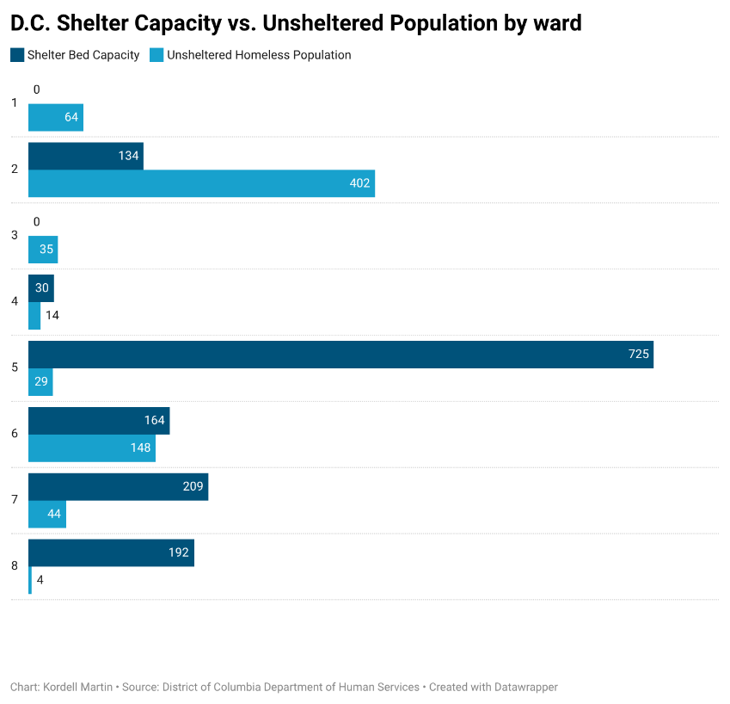
Though the number of beds available in emergency shelters surpasses the total unsheltered population, there are over 5,000 individuals experiencing homelessness in the District, according to the 2025 PIT Count report by the Metropolitan Washington Council of Governments.
DHS said shelter capacity is monitored nightly to determine if additional beds are needed to meet increased demands. Capacity demands can vary at different points of the year, as some shelters are open when weather poses a significant risk to the health of those experiencing homelessness, like hypothermia season, which DHS dates from Nov. 1 to April 15.
If unsheltered individuals can’t find shelter, they may be forced to either stay put or find accommodating facilities outside of their ward. DHS said that people experiencing homelessness can call the District’s Shelter Hotline for free transportation to shelters from anywhere in the city if they can’t find a facility near them.
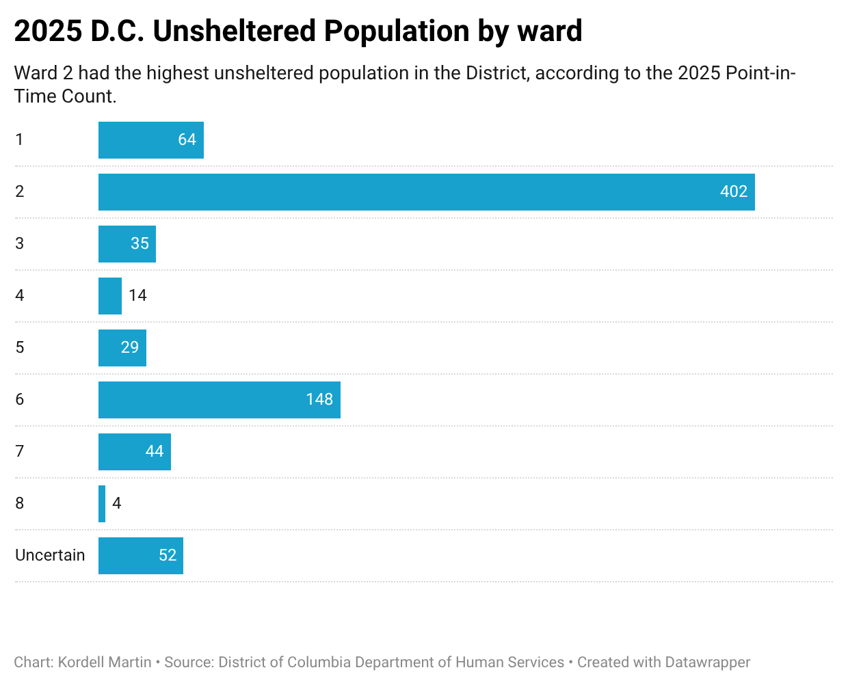
The Patricia Hardy Place for Women, the only low-barrier shelter in Ward 2, has less than half the beds needed to accommodate the ward’s total unsheltered population. Since the facility is dedicated to only sheltering women, men experiencing homelessness in Ward 2 may have to travel for shelter.
Adult men make up about 70% of unaccompanied individuals experiencing homelessness in the District, according to the 2025 PIT Count report by the Metropolitan Washington COG. There are currently no emergency shelter sites in Ward 2 that serve men experiencing homelessness.

